SET 8 – EMPLOYEE PERFORMANCE ANALYSIS
Aim
To analyze employee performance using a line chart, bar chart, and table in R.
Algorithm
- Create the employee performance dataset.
- Store Employee ID, Department, Years of Service, and Performance Score.
- Create a line chart to show employee performance trend.
- Create a bar chart to show employees across departments.
- Display the employee data as a table.
- Add suitable titles and labels.
R Program
library(ggplot2)

employee <- data.frame(
ID = c(1,2,3),
Department = c("Sales","HR","Marketing"),
Years = c(5,3,7),
Score = c(85,92,78)
)

ggplot(employee, aes(Years, Score)) +
geom_line() +
geom_point() +
labs(title="Employee Performance Trend",
x="Years of Service", y="Performance Score")

ggplot(employee, aes(Department, Score, fill=Department)) +
geom_bar(stat="identity") +
labs(title="Employee Performance by Department",
x="Department", y="Performance Score")

print(employee)
OUTPUT:
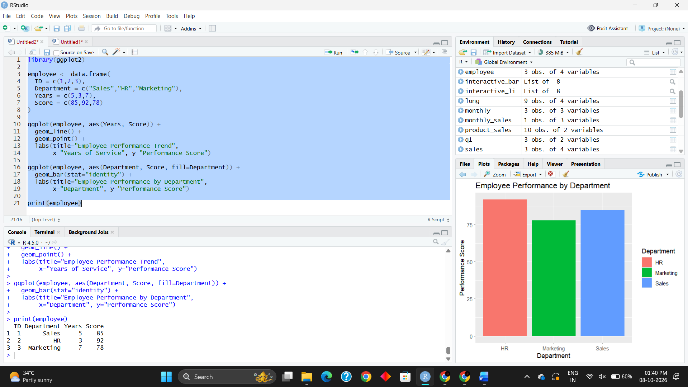

Result
The line chart successfully shows the employee performance trend with respect to years of service. The bar chart displays performance scores across departments, and the table presents the complete employee performance data

